

Packet Tracer - Configure Named Standard IPv4 ACLs

Nombre: Luis Enrique Pérez Señalin

# Addressing Table

|  |  |  |  |  |
| --- | --- | --- | --- | --- |
| **Device** | **Interface** | **IP Address** | **Subnet Mask** | **Default Gateway** |
| R1 | F0/0 | 192.168.100.1 | 255.255.255.0 | N/A |
|  | F0/1 | 192.168.200.1 | 255.255.255.0 |  |
|  | E0/0/0 | 192.168.10.1 | 255.255.255.0 |  |
|  | E0/1/0 | 192.168.20.1 | 255.255.255.0 |  |
| File Server | NIC | 192.168.200.100 | 255.255.255.0 | 192.168.200.1 |
| Web Server | NIC | 192.168.100.100 | 255.255.255.0 | 192.168.100.1 |
| PC0 | NIC | 192.168.20.3 | 255.255.255.0 | 192.168.20.1 |
| PC1 | NIC | 192.168.20.4 | 255.255.255.0 | 192.168.20.1 |
| PC2 | NIC | 192.168.10.3 | 255.255.255.0 | 192.168.10.1 |

**Objectives**

**Part 1: Configure and Apply a Named Standard ACL Part 2: Verify the ACL Implementation**

# Background / Scenario

The senior network administrator has asked you to create a standard named ACL to prevent access to a file server. The file server contains the data base for the web applications. Only the Web Manager workstation PC1 and the Web Server need to access the File Server. All other traffic to the File Server should be denied.

# Instructions

**Part 1: Configure and Apply a Named Standard ACL**

## Step 1: Verify connectivity before the ACL is configured and applied.

All three workstations should be able to ping both the **Web Server** and **File Server**.

## Step 2: Configure a named standard ACL.

1. Configure the following named ACL on **R1**.

### R1(config)# ip access-list standard File_Server_Restrictions

R1(config-std-nacl)# **permit host 192.168.20.4** R1(config-std-nacl)# **permit host 192.168.100.100** R1(config-std-nacl)# **deny any**

**Note**: For scoring purposes, the ACL name is case-sensitive, and the statements must be in the same order as shown.

### Packet Tracer - Configure Named Standard IPv4 ACLs

1. Use the **show access-lists** command to verify the contents of the access list before applying it to an interface. Make sure you have not mistyped any IP addresses and that the statements are in the correct order.

### R1# show access-lists

Standard IP access list File_Server_Restrictions 10 permit host 192.168.20.4

20 permit host 192.168.100.100

30 deny any

## Step 3: Apply the named ACL.

1. Apply the ACL outbound on the Fast Ethernet 0/1 interface.

**Note**: In an actual operational network, applying an access list to an active interface is not a good practice and should be avoided if possible.

R1(config-if)# **ip access-group File_Server_Restrictions out**

1. Save the configuration.

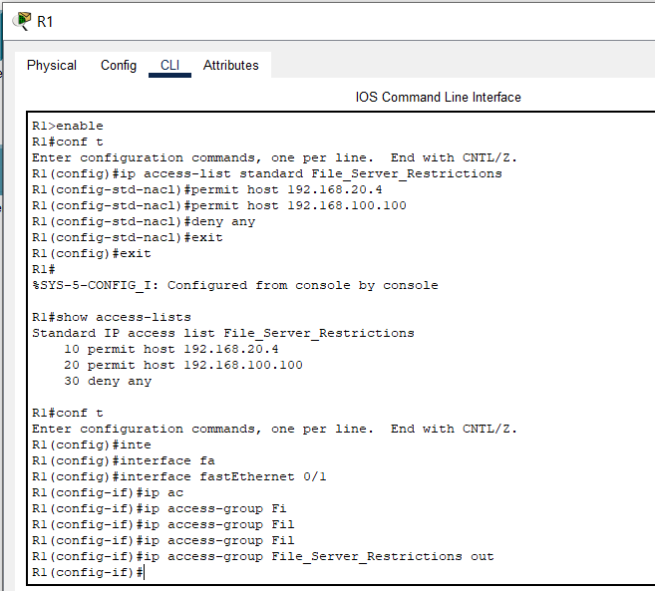

# Part 2: Verify the ACL Implementation

## Step 1: Verify the ACL configuration and application to the interface.

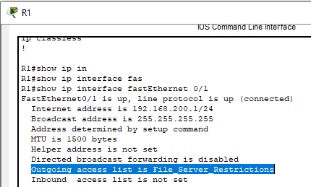Use the **show access-lists** command to verify the ACL configuration. Use the **show run** or **show ip interface fastethernet 0/1** command to verify that the ACL is applied correctly to the interface.

## Step 2: Verify that the ACL is working properly.

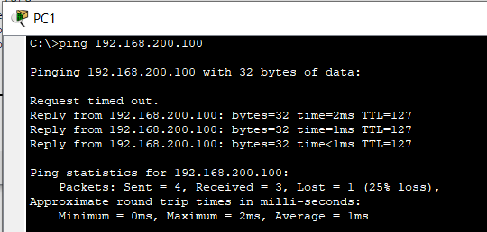All three workstations should be able to ping the **Web Server**, but only **PC1** and the **Web Server** should be able to ping the **File Server**. Repeat the **show access-lists** command to see the number of packets that matched each statement.

Captura de pantalla:

Observación:

El archivo .pka no pidió el ingreso del nombre como normalmente lo hace.